SET-2

Regulations:
A18

H.T No

Sreenidhi Institute of Science and Technology
(An Autonomous Institution)
Code No: 7HC13 Date: 23-Dec-2019 (FN)

B.Tech II-Year I-Semester External Examination, Dec-2019/Jan-2020 (Regular)
TRANSFORM TECHNIQUES and NUMERICAL METHODS (EcE)

Time: 3 Hours Max.Marks:70

Note: a) No additional answer sheets will be provided.
b) All sub-parts of a question must be answered at one place only, otherwise it will not be valued.
c) Missing data can be assumed suitably.

Part - A Max.Marks:20

Answer all QUESTIONS.

1. | Explain Bisection method in finding the roots of equation. | [2M]
2. | Evaluate 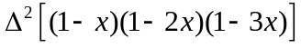 | [2M]
3. | Find the Laplace transform of e^{2t} sin 4t. | [2M]
4. | Evaluate Z(na^{n} ) | [2M]
5. | Form the partial differential equation by eliminating the arbitrary function from z=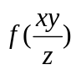 | [2M]
6. | What is Newton’s forward interpolation formula ? | [2M]
7. | Write simpson’s 3/8 th rule. | [2M]
8. | Write Runge-Kutta second and fourth order formulae. | [2M]
9. | Evaluate 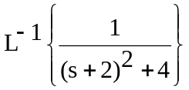 | [2M]
10. | Write one dimensional heat equation and its solution. | [2M]

Part – B Max.Marks:50
ANSWER ANY FIVE QUESTIONS. EACH QUESTION CARRIES 10 MARKS.

11. | a) | Using bisection method find the approximate root of the equation  x⁴-4x-10=0 . | [5M]
 | b) | Evaluate the value of √12 using Newton-Raphson method. | [5M]
12. | a) | Fit a polynomial using Newton’s forward interpolation formula to the following data | [5M]
  x | 40 | 50 | 60 | 70 | 80 | 90
  y | 184 | 206 | 228 | 254 | 278 | 310
 | b) | Find a polynomial using Lagrange’s Interpolation formula to the following data | [5M]
  x | 0 | 2 | 3 | 6
  f(x) | 459 | 605 | 648 | 884
13. |  | Apply Range – Kutta method of 4th order find the approximate value of y when x=0.2 in steps of 0.1, given that  = x+y², y(0) = 1. | [10M]
14. | a) | Find the Laplace transforms of 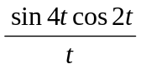. | [5M]
 | b) | Evaluate 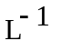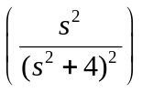. | [5M]
15. | a) | State and prove Damping Rule in Z -Transforms. | [5M]
 | b) | Find Inverse Z transform of 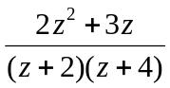 | [5M]
16. | a) | Solve the equation x²p+y²q=z². | [5M]
 | b) | Solve the equation zpq=p+q. | [5M]
17. |  | Using Z- transforms, solve the difference equation u_{n+2}+6u_{n+1}+9u_{n}=2^{n} with u₀=u₁=0. | [10M]
18. |  | Determine the Picards second approximation for the initial value problem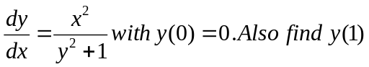 | [10M]

-- 00 -- 00 –

